**CSE 422: Artificial Intelligence**

**Assignment 2**

**Total Marks: 60**

**(Each question carries 20 marks)**

**1. a.** Explain the concept of forward checking with an example.

**b.** Suppose, the following graph represents a map coloring CSP problem. You are trying to color the following graph with 3 colors: Red, Green, and Blue such that no two adjacent nodes have the same color. Node A is already colored Red (R) and node G is colored Green (G).

Assess which node will be visited in the following map coloring example if

**i)** Degree heuristic is used. Explain your answer.

**ii)** According to the Least constraining value heuristic, which color will be

chosen for node B in the given graph? Explain your answer.

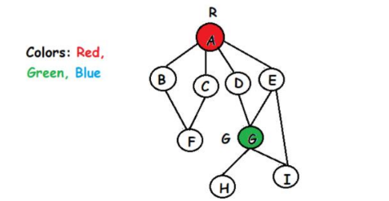

**2.** 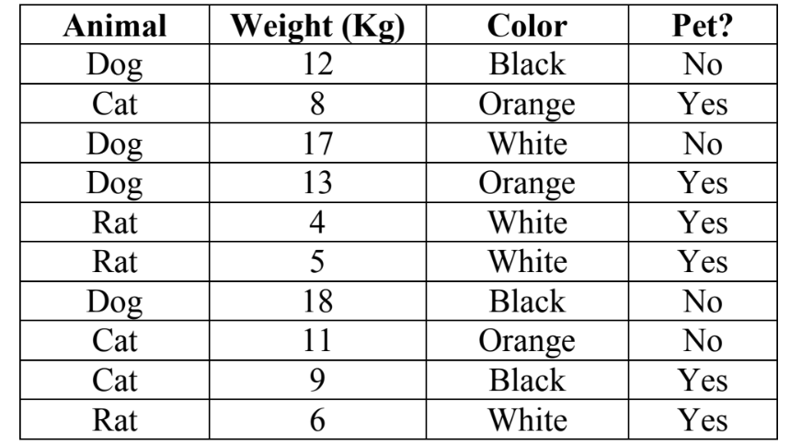

An animal is considered heavy if it weighs more than 10kg. Now, answer the following questions:

**a)** Is dog conditionally independent of heavy if the color is black? Show full calculation. 4

**b)** Given a heavy weighted orange cat, is it more likely to be pet or not? Apply naïve bayes theorem to solve

it. (show learning phase)

**3.** Consider the training data below

**i.** Considering ‘Edible’ as the class, Compute entropy for this dataset.

**ii.** Compute information gain for:

**a)** Color

**b)** Size

**iii.** Compare between Color and Size. Which one is the better feature? Why?

